**Subject:** Database Systems

**Subject Code**: CPSC 50900 -004 (on campus)

**Semester:** Fall 2023

**Project Title:** Shelter for Stray dogs

**Name:** Smitesh Raj

**GitHub URL:** https://github.com/Dante1096

**SQL environment:** Windows

**Week 1:**

Company Name: StrayHaven Shelter Solutions, Inc.

Business Description: StrayHaven Shelter Solutions, Inc. is a non-profit organization dedicated to providing comfortable shelter options for stray dogs using eco-friendly and locally sourced materials.

Supply Chain:

1. Recycled Plastic

- Raw Materials: Recycled plastic.

- Sources:

1. Local Recycling Centers: We collect plastic materials from nearby recycling centers.

2. Donations: Local businesses and individuals donate plastic waste for shelter construction.

2. Bedding

- Raw Materials: Reused blankets, pillows, and cushions.

- Sources:

1. Local Donations: We gather discarded bedding materials from local donations.

2. Secondhand Stores: We purchase used bedding items from charity shops.

3. Natural Light

- Raw Materials: Large windows and eco-friendly heating.

- Sources:

1. Local Suppliers: We source large windows and glass from local suppliers. Also, people who want to help with this project donate this material.

2. Solar Design: Our shelters are designed to harness natural sunlight and heat through their structure.

Primary Office and Operating Cities:

- Primary Office: Our main office is located on the empty ground behind Lewis University near the airport.

- Operating Cities: We serve multiple regions in Illinois, focusing on regions with high numbers of stray dogs, including Chicago, Naperville, Romeoville, etc.

**PART 2:**

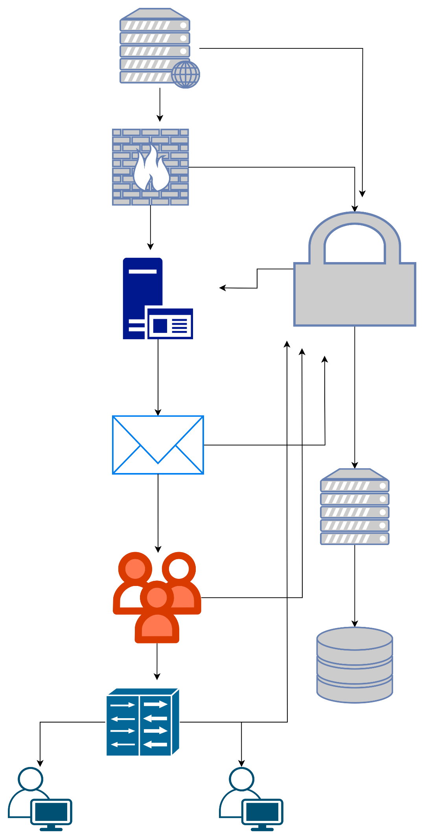

**Week 2:**

1. List 5 entities and provide a short description of each to identify what they are:

1)Shelter

Capacity (integer) - The maximum number of stray dogs the shelter can accommodate.

Location (character) - The geographical location of the shelter.

Construction Material (character) - The type of eco-friendly materials used in the shelter.

2) Recycled Plastic Source

Source Name (character) - The name of the recycling center or donor.

Material Type (character) - Indicates whether the source provides recycled plastic materials.

Quantity Donated (integer) - The amount of recycled plastic donated.

3) Bedding Source

Bedding Source Name (character) - The name of the donation center or secondhand store.

Bedding Material Type (character) - Indicates whether the source provides bedding materials.

Quantity of Bedding Donated (integer) - The amount of bedding materials donated.

4) Natural Light

Shelter Name (character) - The name or identifier of the shelter.

Window Supplier Name (character) - The name of the local supplier or donor providing windows.

Solar Design Availability (boolean) - Indicates whether the shelter is designed to harness natural sunlight and heat (true or false).

5) Volunteer

Volunteer Name (character) - The name of the individual volunteering with the organization.

Contact number (integer) - Contact detail such as phone number

Volunteer Role (character) - The specific role or task the volunteer is assigned within the organization.

**Github:** [**https://github.com/Dante1096**](https://github.com/Dante1096)

**CSV1 Shelter:**

<?xml version="1.0" encoding="UTF-8"?>

<root>

<row>

<Shelter></Shelter>

<FIELD2></FIELD2>

</row>

<row>

<Shelter>Capacity</Shelter>

<FIELD2>Integer</FIELD2>

</row>

<row>

<Shelter>Location</Shelter>

<FIELD2>string</FIELD2>

</row>

<row>

<Shelter>Contruction material</Shelter>

<FIELD2>string</FIELD2>

</row>

</root>

**CSV2 recycled plastic:**

<?xml version="1.0" encoding="UTF-8"?>

<root>

<row>

<Recycled Plastic Source></Recycled Plastic Source>

<FIELD2></FIELD2>

</row>

<row>

<Recycled Plastic Source>Source Name </Recycled Plastic Source>

<FIELD2>string </FIELD2>

</row>

<row>

<Recycled Plastic Source>Material Type </Recycled Plastic Source>

<FIELD2>string </FIELD2>

</row>

<row>

<Recycled Plastic Source>Quantity Donated </Recycled Plastic Source>

<FIELD2>integer</FIELD2>

</row>

</root>

**CSV3 bedding:**

<?xml version="1.0" encoding="UTF-8"?>

<root>

<row>

<Bedding Source></Bedding Source>

<FIELD2></FIELD2>

</row>

<row>

<Bedding Source>Bedding Source Name </Bedding Source>

<FIELD2>string</FIELD2>

</row>

<row>

<Bedding Source>Bedding Material Type </Bedding Source>

<FIELD2>string</FIELD2>

</row>

<row>

<Bedding Source>Quantity of Bedding Donated </Bedding Source>

<FIELD2>integer</FIELD2>

</row>

</root>

**CSV4 Natural light:**

<?xml version="1.0" encoding="UTF-8"?>

<root>

<row>

<Natural light></Natural light>

<FIELD2></FIELD2>

</row>

<row>

<Natural light>Shelter Name</Natural light>

<FIELD2>string</FIELD2>

</row>

<row>

<Natural light>Window supplier name</Natural light>

<FIELD2>string</FIELD2>

</row>

<row>

<Natural light>Solar design availability</Natural light>

<FIELD2>boolean</FIELD2>

</row>

</root>

**CSV5 volunteers**

<?xml version="1.0" encoding="UTF-8"?>

<root>

<row>

<Volunteer></Volunteer>

<FIELD2></FIELD2>

</row>

<row>

<Volunteer>Volunteer Name </Volunteer>

<FIELD2>string</FIELD2>

</row>

<row>

<Volunteer>Contact number </Volunteer>

<FIELD2>integer</FIELD2>

</row>

<row>

<Volunteer>Volunteer Role </Volunteer>

<FIELD2>string</FIELD2>

</row>

</root>

**Week 3:**

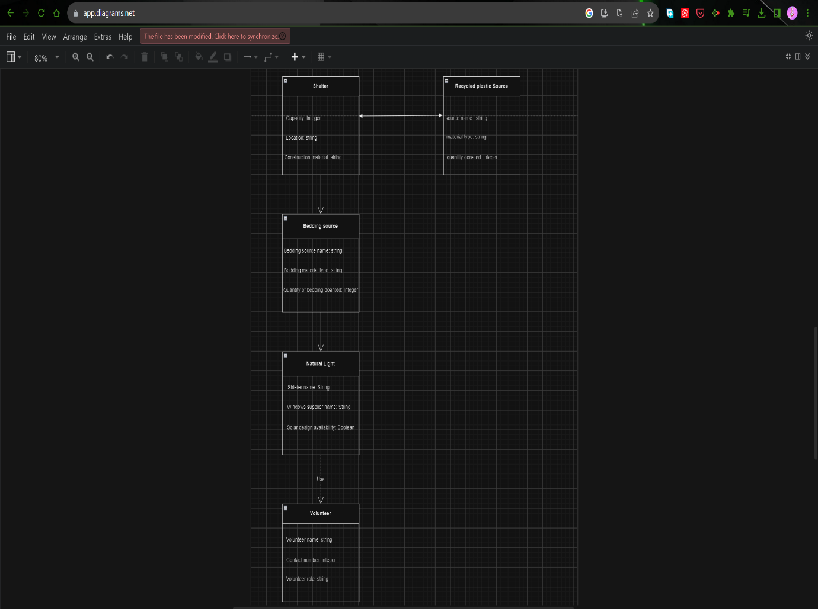



**Relationships between the entities:**

Shelter and Recycled Plastic Source

- Relationship: One-to-Many

- Explanation: One shelter can receive donations from many recycled plastic sources, but each recycled plastic source is associated with only one shelter.

Shelter and Bedding Source:

- Relationship: One-to-Many

- Explanation: Similar to the Recycled Plastic Source relationship, one shelter can receive donations from multiple bedding sources, but each bedding source is associated with only one shelter.

Shelter and Natural Light:

- Relationship: One-to-One

- Explanation: each shelter has a unique natural light setup, it's a one-to-one relationship.

Shelter and Volunteer:

- Relationship: One-to-Many

- Explanation: A shelter can have many volunteers, but each volunteer is associated with only one shelter.